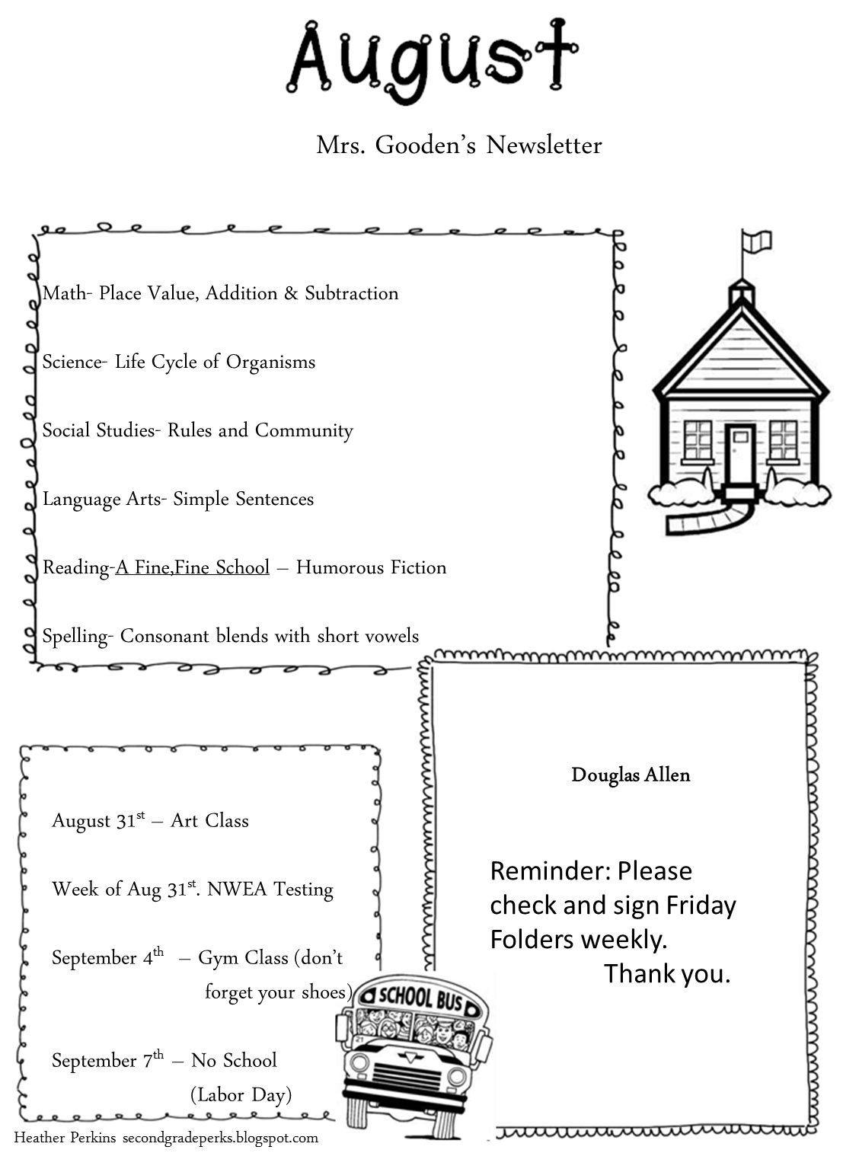

**PATHS KID OF THE WEEK**

Important Dates

**We are learning**